Fire Evacuation Procedures for Killymeal House

April 2022

The purpose of this memo is to inform you of the fire evacuation procedures in Killymeal House. These supersede all procedures issued previously.

- RAISING THE ALARM
If you discover a fire - shout "Fire" and operate the nearest Fire Alarm ‘Break Glass’ Manual Call Point. The fire alarm signal will operate within a few seconds.

The fire alarm signal is a siren with red flashing lights on the ceiling. Fire pagers for anyone with hearing difficulties are available from reception which will vibrate and beep.

Call the Fire and Rescue Service by dialling 999, if using one of the phones within the building please remember you need to dial 9 first for an outside line. Call from a place of safety, preferably outside the building. If you are not certain the Fire and Rescue Service is on its way, call again.

- ACTION TO BE TAKEN ON ACTIVATION OF THE FIRE ALARM
When the fire alarm is activated you must leave the building immediately in an orderly manner. Use the nearest available exit, closing doors as necessary. Do not delay or go back to collect coats or personal belongings. Assist visitors if required and report to your assembly point. The assembly point is on the grass area in front of the Lighthouse Building as shown at the end of this notice.

During an evacuation you must not: -

- stop to collect personal belongings;
- run within the building;
- re-enter the building until advised it is safe; or
- use the lifts

Some drills may require you to use an alternative route to that usually taken so familiarise yourself with the layout of building.

- TEMPORARY OR PERMANENT DISABILITIES
If you are not at ground level and unable to use stairs without assistance, proceed immediately to a designated temporary refuge area which are located in the front and rear lift lobby. Additional instruction will be provided at the refuge area.

Inform your line manager or Fire Precautions Officer (contact details on next page) if you have any condition that affects your ability to leave the building, without assistance. A Personal Emergency Evacuation Plan (PEEP) will be developed for your individual needs. Assistants will be designated if required.

Visitors or members of the public who may need assistance leaving the building in the event of an evacuation should inform reception on arrival so the Fire Precautions Officer can arrange for any assistance as required.

- FIRE WARDENS, FIRE PRECAUTIONS OFFICER
Fire Wardens will check to ensure all areas have been vacated; if they ask you to leave you must do so, without question. Having left the building they will report to the Fire Precautions Officer or Deputy, stationed at the end of the path leading to the front door, and provide details of the progress of the evacuation including details of any people who have not responded appropriately. In the event of a fire the Fire Precautions Officer or Deputy will report to the Senior Fire and Rescue Service Officer.

- TEST PROCEDURES
The fire alarm is tested each week on Friday at approximately 9.00 am, using a different manual call point (break glass). All tests will be preceded by a PA. announcement. Familiarise yourself with the alarm signal and confirm to the Fire Warden that you can hear it. Fire Wardens will advise the Fire Precautions Officer immediately after the test to report on the quality of the alarm signal.

- ACTIVATION OF THE FIRE ALARM – ACCIDENTAL OR OTHERWISE
Regardless of how/why the alarm may have been activated, if the fire alarm is activated you must leave the building immediately using the nearest available exit (see 2. above). As has happened on a number of occasions, it may well be an accidental activation. However, under no circumstances must you remain in the building waiting around for clarification.

If you require further information please contact: -
- Fire Precautions Officer on (028 902) 50037 / Deputy on (028 902) 50040

Issued 08 April 2022

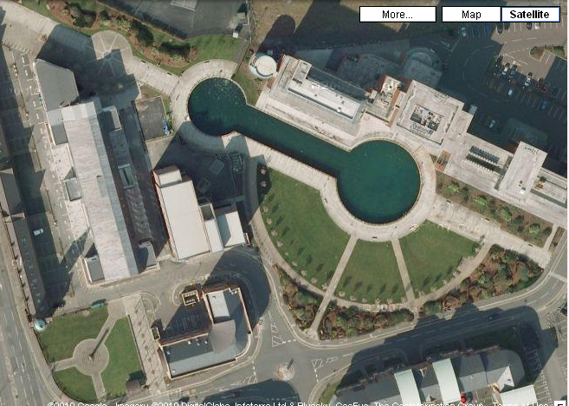
Killymeal
House
Assembly Point

